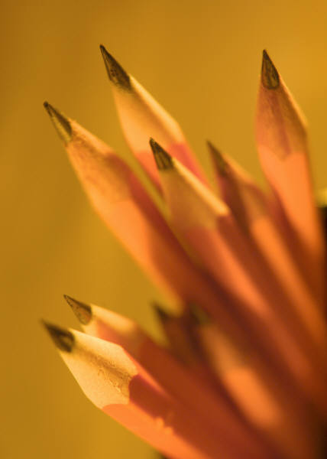

**Lauderdale Middle School**

**7th Grade Team #4 Classroom/ School Supply Lists**

* Scissors
* Glue sticks
* A 1 ½ inch 3-ring Binger and dividers
* 2 Black and White Composition Notebooks per class
* 1 Spiral Notebook
* #2 pencils
* Blue or Black Ink Pens
* 5 folders with pockets and prongs
* Notebook paper
* I Pack of Colored Pencils, crayons, or markers
* 2 Highlighters (different colors)
* 1 Pack of Typing Paper
* 2 Boxes of Kleenex
* 1 Large Hand Sanitizer
* 1 Clorox Wipes
* 1 Can of Disinfectant Spray
* Scotch Tape